Why pointer size is coming 8 while printing ?

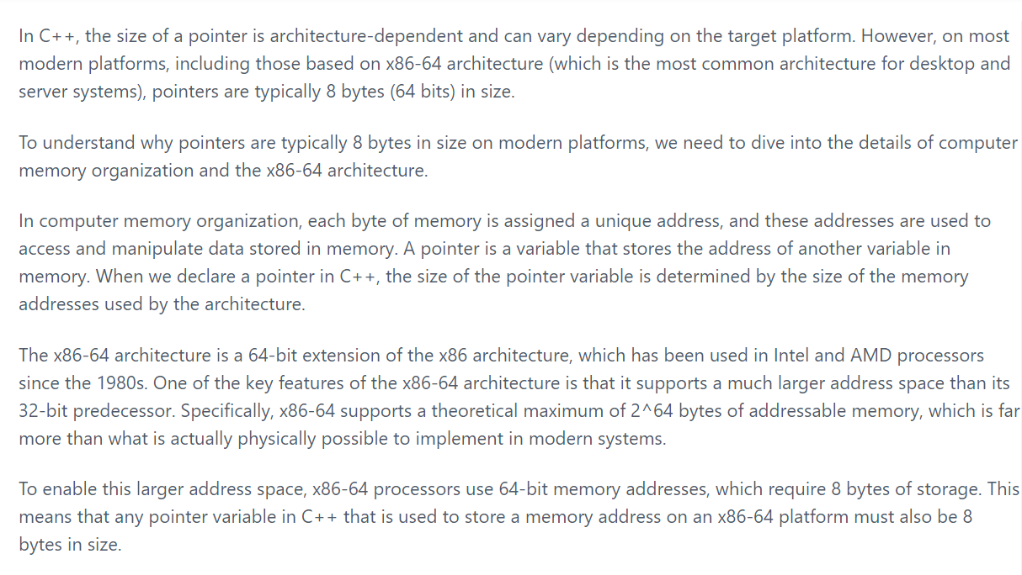

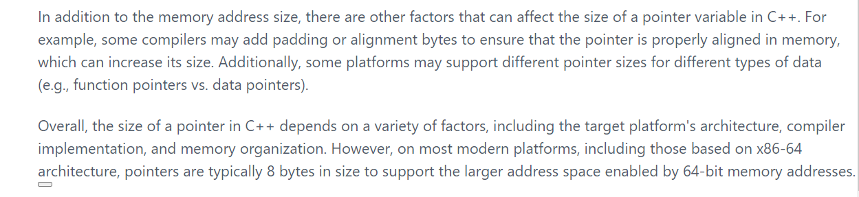

Why we can’t do arr = arr + 1 in c++ ?

